HOME

Colorado's Premier Home Inspection Company

NACHI Certified Home, Mold, and Wood-destroying Organism Inspections
Call now 720-706-8610

Colorado Home Inspections
Colorado Home Inspections offers certified home, mold, and wood-destroying organism inspections. Colorado owned and operated, I pride myself on offering the best home inspections at the best price. Always caring for my clients above all else, I can guarantee that you will be pleased with my services and my professionalism.

Open 7 Days a Week
YOU’LL WANT a Colorado Home Inspections inspector, whom you can work with to evaluate the systems in your home, one that will communicate with you, and educate you along the way. I will not only show you what needs immediate attention, but I’ll talk you through ways in which to maintain your investment.
YOU’LL NEED a Colorado home inspection utilizing state-of-the-art technology and advanced moisture detection equipment to thoroughly evaluate all the components of your home, because sometimes hidden factors can lead to substantial and costly repairs. And, just walking around the house with a camera and a flashlight isn’t enough. I provide detailed and simple to read, computerized reports with digital photos issued to you online within 24 hours.
YOU’LL BENEFIT for many years to come by choosing Colorado Home Inspections, and I know how crucial my performance is to your future. As a Colorado home inspector, I am a member of the National Association of Certified Home Inspectors (NACHI), and I always uphold the highest standards of qualification and continuing education.


Certified Home Inspections
As a NACHI-certified professional home inspector, I have the knowledge and expertise to provide you with an extensive, professional inspection of your prospective property from roof to foundation.


Wood-Destroying Organism Inspections
Wood-Destroying Organisms can cause extreme damage to the integrity and value of a property. Colorado Home Inspections will help you determine whether you are under attack by termites, ants, beetles, bees, and/or Fungi.


Certified Mold Inspections
Colorado Home Inspections offers a thorough, non-invasive mold inspection, utilizing a third-party lab and proven techniques of non-invasive mold detection.


Radon Testing
Exposure to radon causes lung cancer in non-smokers and smokers alike. It is the leading cause of lung cancer in non-smokers. Get your home tested today by our NRPP Certified third-party tester!

Make Sure You Make the Right Decision for Your Investment!
Choose a NACHI Certified Inspector!
720-706-8610

HOME INSPECTIONS

Buying or Selling a Home is a Big Step
Protect yourself from costly expenses and delayed closings!
Call now 720-706-8610
Many people ask: “What all does a home inspection cover?”
At Colorado Home Inspections, we cover everything in your prospective home. We even include a FREE 90 day warranty!
InterNACHI defines a home inspection as follows:
1.1. A general home inspection is a non-invasive, visual examination of the accessible areas of a residential property (as delineated below), performed for a fee, which is designed to identify defects within specific systems and components defined by these Standards that are both observed and deemed material by the inspector. The scope of work may be modified by the Client and Inspector prior to the inspection process.
The general home inspection is based on the observations made on the date of the inspection, and not a prediction of future conditions.
The general home inspection will not reveal every issue that exists or ever could exist, but only those material defects observed on the date of the inspection.

1.2. A material defect is a specific issue with a system or component of a residential property that may have a significant, adverse impact on the value of the property, or that poses an unreasonable risk to people. The fact that a system or component is near, at or beyond the end of its normal useful life is not, in itself, a material defect.

1.3. A general home inspection report shall identify, in written format, defects within specific systems and components defined by these Standards that are both observed and deemed material by the inspector. Inspection reports may include additional comments and recommendations.
To read a full synopsis of what it means to inspect under NACHI certification, visit NACHI.org.

General Home Inspection
Everything From Roof to Foundation
$Priced Per Sq Ft.
- NACHI Certified
- Guaranteed Satisfaction
- Thorough Reporting
- 90 Day Warranty
Schedule Here

What all is inspected in a home inspection?
We follow the NACHI Standards of Practice, which can be found here. The following are some of the many items we will be inspecting:
- Foundation and support structure
- Fireplaces
- Roof systems
- Basement seepage
- Safety controls
- Water heater
- Ventilation
- Electrical capacity and components
- Electrical panel and sub-panels
- Walks and driveways
- Built-in appliances
- Structural integrity
- Steps and stairs
- Heating system
- Central Air Conditioning system
- Plumbing System and Fixtures
- Garages, Carports, Workshops, or other external buildings
- Surface drainage
- Windows and doors
- Insulation
- Gutters and downspouts
- Decks
- Sump pumps

MOLD INSPECTIONS

Mold is a Serious Health Risk
Get your home or business inspected today! 303-625-9909
MANY THINGS CAN CAUSE MOLD TO GROW in a home without a person ever knowing: water intrusion into basements and crawl spaces, leaking plumbing pipes or inadequate ventilation in attics and crawl spaces. The moisture from these items will create a habitat within the floor or walls that will at some point become the perfect breeding ground for mold. Leaking pipes or foundations can be an even bigger problem than leaking sinks and faucets, because the issue can be very hard to find. As a result, people should employ a certified mold inspector to run mold tests in the home. Even if people do not suspect that they have mold development in their home, it would still be a wise idea to have a mold inspection carried out at least once every year.
A CERTIFIED MOLD INSPECTOR will have the necessary equipment to do the mold tests, which will determine the amount of mold, if it is growing, what kind of mold it is and where it is located.

Mold Inspection Service
$295
- Thorough inspection looking for possible cause of mold including but not limited to:
- Water intrusion
- Cracks and leaks
303-625-9909

Mold Lab Fees
Unavoidable fee
$39/sample
- A minimum of two samples must be taken:
- One indoor to test the area
- One outdoor as a control
303-625-9909

Avoid Biased Testers
Call Now to Book Your Mold Inspection 720-706-8610

WOOD DESTROYING ORGANISM INSPECTION

NACHI Certified Wood-Destroying Organisms Inspection
Call now 720-706-8610

Wood Destroying Organism Inspection
$Call for quote/Square-footage
- Inspect for possible entrance from all termites and other WDOs.
- Provide a thorough, digital report within 24 hours.
- High-resolution photos are attached to the report with explanations.
720-706-8610
WOOD-DESTROYING ORGANISMS (WDO) can cause extreme damage to the integrity and value of a property. Colorado Home Inspection Plus will help you determine whether you are under attack by termites, ants, beetles, bees, and/or fungi.
OUR REPORT will include information regarding:
- Photos of any evidence of infestation by termites or other wood-destroying organisms.
- Photos of any damage by termites or other wood destroying organisms.
- A report of any previous treatment for termites or other wood-destroying organisms.
OUR WDO INSPECTION INVOLVES a visual inspection and photo documented report; the written report for the home or property will give you proof of any visible and accessible evidence of an infection or damage by wood-destroying organisms. Usually this means subterranean or dry wood termites, but will also cover wood destroying beetles and wood destroying fungi.
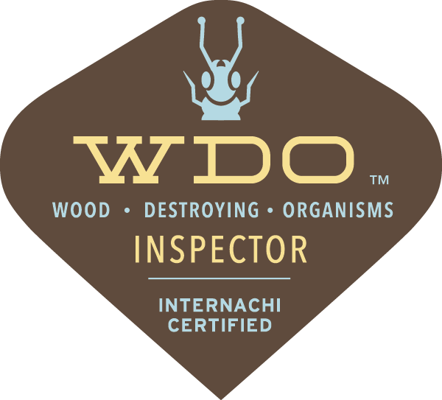

RADON TESTING

NRPP Certified Radon Testing
Radon causes lung cancer! Don’t delay!
720-706-8610
Q

Lung Cancer
Lung Cancer kills thousands of Americans every year. Smoking, radon, and secondhand smoke are the leading causes of lung cancer. Although lung cancer can be treated, the survival rate is one of the lowest for those with cancer. From the time of diagnosis, between 11 and 15 percent of those afflicted will live beyond five years, depending upon demographic factors. In many cases lung cancer can be prevented.
Q

Smoking
Smoking is the leading cause of lung cancer. Smoking causes an estimated 160,000* cancer deaths in the U.S. every year (American Cancer Society, 2004). And the rate among women is rising. On January 11, 1964, Dr. Luther L. Terry, then U.S. Surgeon General, issued the first warning on the link between smoking and lung cancer. Lung cancer now surpasses breast cancer as the number one cause of death among women. A smoker who is also exposed to radon has a much higher risk of lung cancer.
Q

Radon
Radon is the number one cause of lung cancer among non-smokers, according to EPA estimates. Overall, radon is the second leading cause of lung cancer. Radon is responsible for about 21,000 lung cancer deaths every year. About 2,900 of these deaths occur among people who have never smoked. On January 13, 2005, Dr. Richard H. Carmona, the U.S. Surgeon General, issued a national health advisory on radon. Read a study by Dr. William Field on radon-related lung cancer in women here.
Q

Secondhand smoke
Secondhand smoke is the third leading cause of lung cancer and responsible for an estimated 3,000 lung cancer deaths every year. Smoking affects non-smokers by exposing them to secondhand smoke. Exposure to secondhand smoke can have serious consequences for children’s health, including asthma attacks, affecting the respiratory tract (bronchitis, pneumonia) and may cause ear infections.
Q

Studies Find Direct Evidence Linking Radon in Homes to Lung Cancer
(2005) Two studies show definitive evidence of an association between residential radon exposure and lung cancer. Two studies, a North American study and a European study, both combined data from several previous residential studies. These two studies go a step beyond earlier findings. They confirm the radon health risks predicted by occupational studies of underground miner’s who breathed radon for a period of years. Early in the debate about radon-related risks, some researchers questioned whether occupational studies could be used to calculate risks from exposure to radon in the home environment. “These findings effectively end any doubts about the risks to Americans of having radon in their homes,” said Tom Kelly, Former Director of EPA’s Indoor Environments Division. “We know that radon is a carcinogen. This research confirms that breathing low levels of radon can lead to lung cancer.”

LOWEST PRICE GUARANTEE

Colorado Home Inspections will provide the most competitive pricing, GUARANTEED.
Call now 720-706-8610
COMPETITIVE PRICING in-line with most other certified and insured Colorado Home Inspectors in the Denver Area.
DOES IT REALLY MAKE SENSE TO CUT CORNERS and hire a less qualified person to handle something as important as your home inspection? The Best Value is not always the lowest price. Colorado Home Inspections provides high quality service at a competitive price so you know you’re getting the best of the business.
YOU WANT TO BE ABLE TO count on your Home Inspection Report as being accurate and complete. You can trust our Colorado Home Inspectors to provide just that.
WE WILL MATCH ANY PRICE. If you get a quote from another company at a lower price and they have the same qualifications as we do, we will match that price. We believe in giving you what you deserve in both service and cost.

CERTIFICATIONS

I am a member in good standing with the National Association of Certified Home Inspectors (NACHI). Members of NACHI are the most educated and best trained inspectors in the world.
Call now 720-706-8610
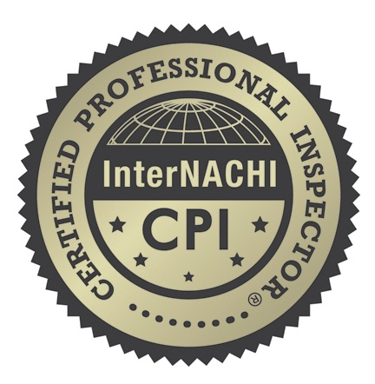
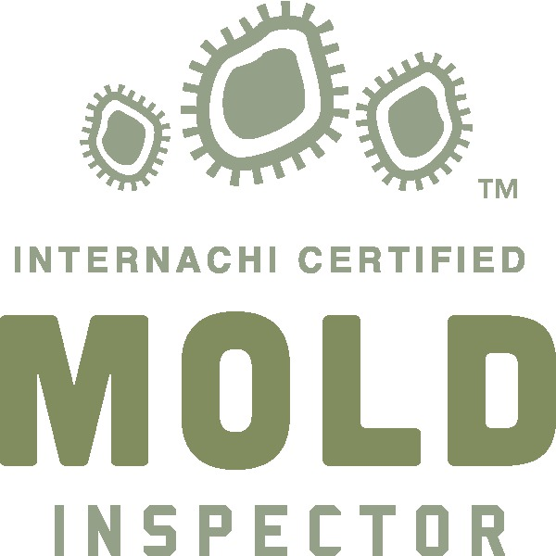

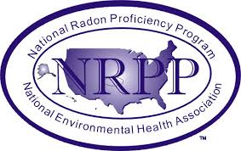

DIGITAL REPORTS

Comprehensive, Digital Reports
Sent out automatically within 24 hours of your home inspection!
Call Us at 720-706-8610
We provide completed reports within 24 hours from your Colorado home inspection. We do not believe in rushing through typing your report on site. If you need your report sooner, we do provide same day reports at no additional charge. We will provide full color digital pictures and full narrative descriptions for each area of concern delivered to you online. You can view, print, and electronically forward your report to agents, brokers, or friends and family for review.

CONTACT

REVIEWS
1,920

Check Out All Our Happy Customers!

REFERRALS

Radon Mitigations
Axium’s Colorado Radon Mitigation team is a leader in the radon mitigation industry. They design and install top of the line radon abatement systems throughout Colorado. Axium Radon Mitigations is:
- Certified & State Listed
- Insured & Bonded
- Provide a Lifetime Warranty on their systems
- Do not use subcontractors
- 110% Best Price Guarantee
- Accredited & Trusted

Call Axium Radon Mitigation
303-800-2439

Lead & Asbestos Testing
Axium Inspections has fully trained, certified, and experienced Denver lead & asbestos testing inspectors. They are fully bonded and insured. Avoid a conflict of interest. An asbestos professional hired to assess the need for asbestos repair or removal should not be connected with an asbestos firm that does the actual repair or removal of materials.

Call Axium Environmental
303-800-2439

Sewer Scope
Sewer inspectors utilize long cameras and go inside the sewer line to view imperfections in a property’s the sewer line in the case that there might be some cracks, off-sets, or any other damage that could affect the health of the sewer line. Sewer Optics provides:
- Full written & video report
- 7am-7pm Customer Service
- Run by a master plumber

Call Sewer Optics
303-843-7280

Drone Inspections
- Real Estate Aerial Inspections & Photography
- Commercial Aerial Inspections & Photography
- Agricultural Inspections & Photography

Call Telos Aerial
(720) 229-0444

EIFIS/Stucco Inspection
The purpose of a stucco inspection is to look for visible installation flaws, inadequate water diversion, sealant failure and if necessary, conduct moisture readings as appropriate. This inspection can alert you to hidden problems that could cost thousands of dollars to fix.

Call Huffman Inspections
303-840-8722

Mold, Flood & Fire Mitigation
With 24/7 emergency services, Colorado Cleanup Services is your One-Stop-Shop for all your remediation and reconstruction needs.
CCS Provides:
- Water Extraction
- Fire Damage Cleanup
- Hoarding Cleanup
- Trauma Cleanup
- Mold Remediation

Call CCS
303-237-4406

Lead, Asbestos & Meth Abatement
DS Environmental has distinguished itself in the industry by providing a full spectrum of environmental services at every level while upholding only the highest of industry standards. Through tireless dedication, they have become the foremost experts on environmental laws and regulations while simultaneously focusing on building lasting relationships through superior customer service.
Their services include:
- Asbestos Abatement
- Lead Abatement
- Mold Remediation
- Air Quality Testing
- Phase Inspections
- Meth Testing

Call DS Consulting
(970) 476-4182
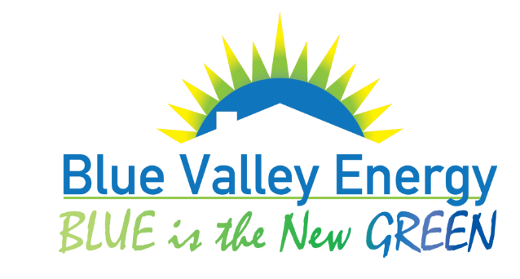

HVAC
Blue Valley Energy has been the preferred heating, cooling, and geothermal provider in Longmont for over 30 years. They can repair, service, or install any aspect of residential or commercial heating and cooling systems. They provide dependable air conditioning and heating systems for your comfort at a great value. They are long term Longmont residents , committed to our community and have earned our reputation as the best HVAC company in town.

Call Blue Valley Energy
303-993-2645

